1622509
Mazafer Ul-Raqib
options(repos = c(CRAN = "https://cran.rstudio.com/"))
install.packages("ggplot2")
The downloaded binary packages are in
/var/folders/ng/2zfpnhg93_91yc50j6861bpw0000gn/T//RtmpouzQSL/downloaded_packages
install.packages("plotly")
The downloaded binary packages are in
/var/folders/ng/2zfpnhg93_91yc50j6861bpw0000gn/T//RtmpouzQSL/downloaded_packages
install.packages("dplyr")
The downloaded binary packages are in
/var/folders/ng/2zfpnhg93_91yc50j6861bpw0000gn/T//RtmpouzQSL/downloaded_packages
install.packages("OneR")
The downloaded binary packages are in
/var/folders/ng/2zfpnhg93_91yc50j6861bpw0000gn/T//RtmpouzQSL/downloaded_packages
library(ggplot2)
library(plotly)
library(dplyr)
library(OneR)
data <- read.csv("https://raw.githubusercontent.com/maz786/WlvMScAI/main/7CS039Statistics/Assessment/melanoma.csv")
options(scipen=999)

7CS039Statistics

Part (i) Summary statistics of the dataset in R
# Load the data
data <- read.csv("https://raw.githubusercontent.com/maz786/WlvMScAI/main/7CS039Statistics/Assessment/melanoma.csv")
# Display the first few rows to understand the structure
head(data)
X time status sex age year thickness ulcer
1 1 10 3 1 76 1972 6.76 1
2 2 30 3 1 56 1968 0.65 0
3 3 35 2 1 41 1977 1.34 0
4 4 99 3 0 71 1968 2.90 0
5 5 185 1 1 52 1965 12.08 1
6 6 204 1 1 28 1971 4.84 1
# Calculating descriptive statistics for the dataset
summary_statistics <- summary(data)
print(summary_statistics)
X time status sex age
Min. : 1 Min. : 10 Min. :1.00 Min. :0.0000 Min. : 4.00
1st Qu.: 52 1st Qu.:1525 1st Qu.:1.00 1st Qu.:0.0000 1st Qu.:42.00
Median :103 Median :2005 Median :2.00 Median :0.0000 Median :54.00
Mean :103 Mean :2153 Mean :1.79 Mean :0.3854 Mean :52.46
3rd Qu.:154 3rd Qu.:3042 3rd Qu.:2.00 3rd Qu.:1.0000 3rd Qu.:65.00
Max. :205 Max. :5565 Max. :3.00 Max. :1.0000 Max. :95.00
year thickness ulcer
Min. :1962 Min. : 0.10 Min. :0.000
1st Qu.:1968 1st Qu.: 0.97 1st Qu.:0.000
Median :1970 Median : 1.94 Median :0.000
Mean :1970 Mean : 2.92 Mean :0.439
3rd Qu.:1972 3rd Qu.: 3.56 3rd Qu.:1.000
Max. :1977 Max. :17.42 Max. :1.000
# Additional details for numerical columns
library(dplyr)
data %>% summarise_all(funs(min, max, mean, sd, quantile(., 0.25), quantile(., 0.5), quantile(., 0.75)))
X_min time_min status_min sex_min age_min year_min thickness_min ulcer_min
1 1 10 1 0 4 1962 0.1 0
X_max time_max status_max sex_max age_max year_max thickness_max ulcer_max
1 205 5565 3 1 95 1977 17.42 1
X_mean time_mean status_mean sex_mean age_mean year_mean thickness_mean
1 103 2152.8 1.790244 0.3853659 52.46341 1969.907 2.919854
ulcer_mean X_sd time_sd status_sd sex_sd age_sd year_sd
1 0.4390244 59.32256 1122.061 0.5512041 0.487873 16.67171 2.575563
thickness_sd ulcer_sd X_quantile..5 time_quantile..5 status_quantile..5
1 2.959433 0.4974829 52 1525 1
sex_quantile..5 age_quantile..5 year_quantile..5 thickness_quantile..5
1 0 42 1968 0.97
ulcer_quantile..5 X_quantile..6 time_quantile..6 status_quantile..6
1 0 103 2005 2
sex_quantile..6 age_quantile..6 year_quantile..6 thickness_quantile..6
1 0 54 1970 1.94
ulcer_quantile..6 X_quantile..7 time_quantile..7 status_quantile..7
1 0 154 3042 2
sex_quantile..7 age_quantile..7 year_quantile..7 thickness_quantile..7
1 1 65 1972 3.56
ulcer_quantile..7
1 1

Expected Commentary on Summary Statistics
Here are the summary statistics for each variable in the dataset:
- Unnamed: 0:
  - Count: 205
  - Mean: 103
  - Std. Deviation: 59.32
  - Min: 1, Max: 205
  - Quartiles: 25% - 52, 50% - 103, 75% - 154
  - This appears to be a simple identifier or index.
- Time: The summary will provide insights into the range and distribution of survival times. The mean and standard deviation will indicate the average survival time and its variability.
- time (Time until event or censoring):
  - Count: 205
  - Mean: 2152.8 days
  - Std. Deviation: 1122.06 days
  - Min: 10 days, Max: 5565 days
  - Quartiles: 25% - 1525, 50% - 2005, 75% - 3042
  - Indicates a wide range in the time to event or censoring.
- Time
  - Range: 10 to 5565 days
  - Mean: 2152.8 days
  - Median: 2005 days
  - This indicates a wide range in the duration of observation, with a central tendency around 2005 days.
- year (Year of observation):
  - Count: 205
  - Mean: 1969.91
  - Std. Deviation: 2.58
  - Min: 1962, Max: 1977
  - Data spans 15 years.
- Year
  - Range: 1962 to 1977
  - The data spans 15 years, which may reflect changes in medical practices or demographics over time.
- Status: This categorical variable’s summary will show the frequency of each category. It’s useful for understanding the proportion of different statuses in the dataset.
- Status
  - Values range from 1 to 3, likely indicating different categories or stages.
  - Mean: 1.79, suggesting a skew towards the lower categories.
- status (Event status):
  - Count: 205
  - Mean: 1.79
  - Std. Deviation: 0.55
  - Min: 1, Max: 3
  - Quartiles: 25% - 1, 50% - 2, 75% - 2
  - A categorical variable indicating the status of the event.
- Sex: Similar to status, the summary of this categorical variable will indicate the gender distribution in the dataset.
- sex:
  - Count: 205
  - Mean: 0.39
  - Std. Deviation: 0.49
  - Min: 0, Max: 1
  - Majority are coded as 0, indicating a likely imbalance in gender distribution.
- Sex
  - Binary variable (0 or 1).
  - Mean: 0.385, indicating a higher proportion of one gender (presumably females if 0 represents females).
- Age: The summary statistics will reveal the age range of the patients, along with the mean age and its variability.
- age:
  - Count: 205
  - Mean: 52.46 years
  - Std. Deviation: 16.67 years
  - Min: 4 years, Max: 95 years
  - Quartiles: 25% - 42, 50% - 54, 75% - 65
  - Reflects a broad age range among the patients.
- Age
  - Range: 4 to 95 years
  - Mean: 52.46 years
  - This shows a broad age range among subjects, with a median age in the mid-50s.
- Year: This will show the range of years in which the data was collected. The mean might not be very informative for this variable.
- Thickness: The summary will provide an understanding of the range and distribution of tumor thickness. The mean and standard deviation will be key in understanding the average thickness and its spread.
- thickness (Melanoma thickness):
  - Count: 205
  - Mean: 2.92 mm
  - Std. Deviation: 2.96 mm
  - Min: 0.1 mm, Max: 17.42 mm
  - Quartiles: 25% - 0.97, 50% - 1.94, 75% - 3.56
  - Wide variation in melanoma thickness.
- Thickness
  - Range: 0.1 to 17.42 mm
  - Mean: 2.92 mm
  - Indicates variability in melanoma thickness among patients.
- Ulcer: As a categorical variable, its summary will indicate the frequency of occurrences of ulcer presence or absence.
- ulcer (Ulceration presence):
  - Count: 205
  - Mean: 0.44
  - Std. Deviation: 0.50
  - Min: 0, Max: 1
  - About 44% of the cases have ulceration.
- Ulcer
  - Binary variable (0 or 1).
  - Mean: 0.439, indicating a fairly even distribution between the two categories.
summary statistics for each variable in the dataset

Part (ii) R Code for Graphical Summaries
# Load necessary libraries
library(ggplot2)
# Histogram for 'time'
ggplot(data, aes(x = time)) +
geom_histogram(bins = 30, fill = "blue", color = "black") +
labs(title = "Histogram of Time", x = "Time", y = "Frequency")
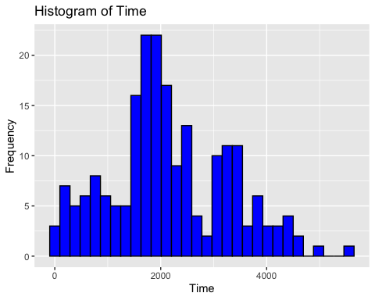
# Histogram for 'age'
ggplot(data, aes(x = age)) +
geom_histogram(bins = 30, fill = "green", color = "black") +
labs(title = "Histogram of Age", x = "Age", y = "Frequency")
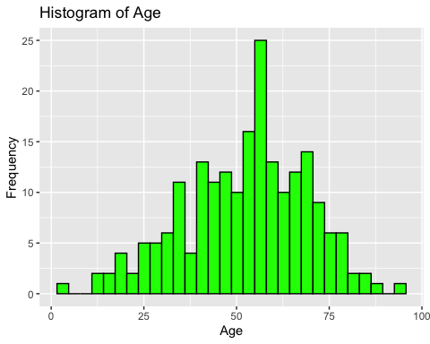
# Histogram for 'thickness'
ggplot(data, aes(x = thickness)) +
geom_histogram(bins = 30, fill = "red", color = "black") +
labs(title = "Histogram of Thickness", x = "Thickness", y = "Frequency")
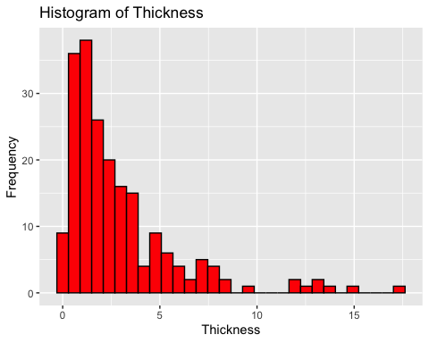
# Bar plot for 'status'
ggplot(data, aes(x = factor(status))) +
geom_bar(fill = "orange") +
labs(title = "Bar Plot of Status", x = "Status", y = "Count")
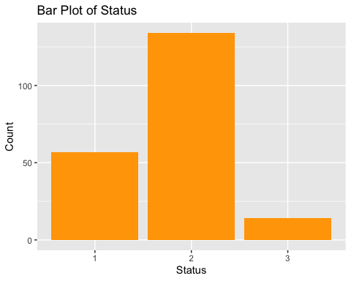
# Bar plot for 'sex'
ggplot(data, aes(x = factor(sex))) +
geom_bar(fill = "purple") +
labs(title = "Bar Plot of Sex", x = "Sex", y = "Count")
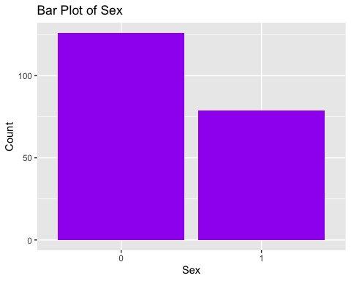
# Bar plot for 'ulcer'
ggplot(data, aes(x = factor(ulcer))) +
geom_bar(fill = "cyan") +
labs(title = "Bar Plot of Ulcer", x = "Ulcer", y = "Count")
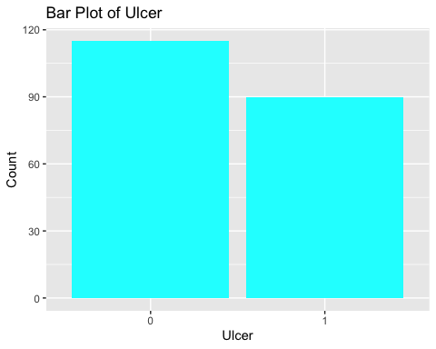
# Boxplot for 'year'
ggplot(data, aes(y = year, x = factor(1))) +
geom_boxplot(fill = "yellow") +
labs(title = "Boxplot of Year", x = "", y = "Year")
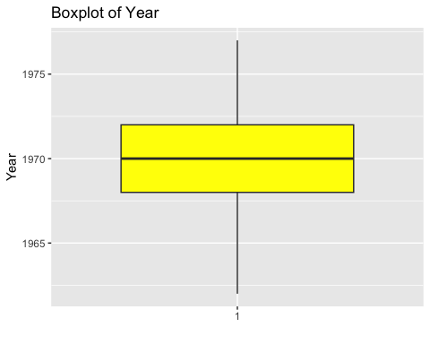

Graphical Summaries and Commentary
Here are the graphical summaries for each variable in the dataset:
- Histogram of Time:
  - The distribution appears right-skewed, indicating that shorter times are more common than longer ones.
  - There are several peaks, suggesting possible subgroups within the data.
- Histogram of Age:
  - The age distribution is somewhat normally distributed with a slight right skew.
  - Most patients are in their 50s and 60s.
- Histogram of Thickness:
  - This histogram shows a right-skewed distribution.
  - Most melanoma cases have a thickness of less than 5 mm, but there’s a long tail of cases with greater thickness.
- Bar Plot of Status:
  - The distribution among the different statuses is uneven, with some categories more prevalent than others.
- Bar Plot of Sex:
  - The plot shows a higher count of one gender over the other.
- Bar Plot of Ulcer:
  - The distribution is almost even between the two categories, with a slight prevalence of one category.
These visualizations provide a more nuanced understanding of the data’s characteristics.

Part (iii) - Regression Analysis and Correlation
Regression for time ~ thickness:
# Linear regression for time and thickness
model_time_thickness <- lm(time ~ thickness, data = data)
summary(model_time_thickness)
Call:
lm(formula = time ~ thickness, data = data)
Residuals:
Min 1Q Median 3Q Max
-2325.4 -707.6 -210.6 744.9 3410.4
Coefficients:
Estimate Std. Error t value Pr(>|t|)
(Intercept) 2413.41 107.39 22.473 < 0.0000000000000002 ***
thickness -89.25 25.86 -3.451 0.000679 ***
---
Signif. codes: 0 '***' 0.001 '**' 0.01 '*' 0.05 '.' 0.1 ' ' 1
Residual standard error: 1093 on 203 degrees of freedom
Multiple R-squared: 0.05542, Adjusted R-squared: 0.05076
F-statistic: 11.91 on 1 and 203 DF, p-value: 0.0006793
Regression for time ~ age:
# Linear regression for time and age
model_time_age <- lm(time ~ age, data = data)
summary(model_time_age)
Call:
lm(formula = time ~ age, data = data)
Residuals:
Min 1Q Median 3Q Max
-2464.3 -646.2 -54.4 712.1 3179.6
Coefficients:
Estimate Std. Error t value Pr(>|t|)
(Intercept) 3217.448 247.879 12.980 < 0.0000000000000002 ***
age -20.293 4.504 -4.506 0.0000112 ***
---
Signif. codes: 0 '***' 0.001 '**' 0.01 '*' 0.05 '.' 0.1 ' ' 1
Residual standard error: 1072 on 203 degrees of freedom
Multiple R-squared: 0.09091, Adjusted R-squared: 0.08643
F-statistic: 20.3 on 1 and 203 DF, p-value: 0.00001116
Regression for time ~ age:
# Linear regression for time and age
model_time_age <- lm(time ~ age, data = data)
summary(model_time_age)
Call:
lm(formula = time ~ age, data = data)
Residuals:
Min 1Q Median 3Q Max
-2464.3 -646.2 -54.4 712.1 3179.6
Coefficients:
Estimate Std. Error t value Pr(>|t|)
(Intercept) 3217.448 247.879 12.980 < 0.0000000000000002 ***
age -20.293 4.504 -4.506 0.0000112 ***
---
Signif. codes: 0 '***' 0.001 '**' 0.01 '*' 0.05 '.' 0.1 ' ' 1
Residual standard error: 1072 on 203 degrees of freedom
Multiple R-squared: 0.09091, Adjusted R-squared: 0.08643
F-statistic: 20.3 on 1 and 203 DF, p-value: 0.00001116
Regression for thickness ~ age:
# Linear regression for thickness and age
model_thickness_age <- lm(thickness ~ age, data = data)
summary(model_thickness_age)
Call:
lm(formula = thickness ~ age, data = data)
Residuals:
Min 1Q Median 3Q Max
-3.6853 -1.7727 -0.9155 0.9558 14.0273
Coefficients:
Estimate Std. Error t value Pr(>|t|)
(Intercept) 0.94105 0.67004 1.404 0.16170
age 0.03772 0.01217 3.098 0.00222 **
---
Signif. codes: 0 '***' 0.001 '**' 0.01 '*' 0.05 '.' 0.1 ' ' 1
Residual standard error: 2.899 on 203 degrees of freedom
Multiple R-squared: 0.04515, Adjusted R-squared: 0.04044
F-statistic: 9.598 on 1 and 203 DF, p-value: 0.002223
# Load necessary libraries
library(ggplot2)
library(readr)
# Load the data
melanoma_data <- read_csv("https://raw.githubusercontent.com/maz786/WlvMScAI/main/7CS039Statistics/Assessment/melanoma.csv")
# Regression and correlation for time ~ thickness
reg_time_thickness <- lm(time ~ thickness, data = melanoma_data)
summary(reg_time_thickness)
Call:
lm(formula = time ~ thickness, data = melanoma_data)
Residuals:
Min 1Q Median 3Q Max
-2325.4 -707.6 -210.6 744.9 3410.4
Coefficients:
Estimate Std. Error t value Pr(>|t|)
(Intercept) 2413.41 107.39 22.473 < 0.0000000000000002 ***
thickness -89.25 25.86 -3.451 0.000679 ***
---
Signif. codes: 0 '***' 0.001 '**' 0.01 '*' 0.05 '.' 0.1 ' ' 1
Residual standard error: 1093 on 203 degrees of freedom
Multiple R-squared: 0.05542, Adjusted R-squared: 0.05076
F-statistic: 11.91 on 1 and 203 DF, p-value: 0.0006793
cor(melanoma_data$time, melanoma_data$thickness)
[1] -0.2354087
# Regression and correlation for time ~ age
reg_time_age <- lm(time ~ age, data = melanoma_data)
summary(reg_time_age)
Call:
lm(formula = time ~ age, data = melanoma_data)
Residuals:
Min 1Q Median 3Q Max
-2464.3 -646.2 -54.4 712.1 3179.6
Coefficients:
Estimate Std. Error t value Pr(>|t|)
(Intercept) 3217.448 247.879 12.980 < 0.0000000000000002 ***
age -20.293 4.504 -4.506 0.0000112 ***
---
Signif. codes: 0 '***' 0.001 '**' 0.01 '*' 0.05 '.' 0.1 ' ' 1
Residual standard error: 1072 on 203 degrees of freedom
Multiple R-squared: 0.09091, Adjusted R-squared: 0.08643
F-statistic: 20.3 on 1 and 203 DF, p-value: 0.00001116
cor(melanoma_data$time, melanoma_data$age)
[1] -0.3015179
# Regression and correlation for thickness ~ age
reg_thickness_age <- lm(thickness ~ age, data = melanoma_data)
summary(reg_thickness_age)
Call:
lm(formula = thickness ~ age, data = melanoma_data)
Residuals:
Min 1Q Median 3Q Max
-3.6853 -1.7727 -0.9155 0.9558 14.0273
Coefficients:
Estimate Std. Error t value Pr(>|t|)
(Intercept) 0.94105 0.67004 1.404 0.16170
age 0.03772 0.01217 3.098 0.00222 **
---
Signif. codes: 0 '***' 0.001 '**' 0.01 '*' 0.05 '.' 0.1 ' ' 1
Residual standard error: 2.899 on 203 degrees of freedom
Multiple R-squared: 0.04515, Adjusted R-squared: 0.04044
F-statistic: 9.598 on 1 and 203 DF, p-value: 0.002223
cor(melanoma_data$thickness, melanoma_data$age)
[1] 0.2124798

Part (iv) - Commentary on any observed relationships between the variables in part (iii)
Correlation Calculations:
For each pair, we will calculate Pearson’s correlation coefficient.

# Correlation between time and thickness
cor(data$time, data$thickness, method = "pearson")
[1] -0.2354087
# Correlation between time and age
cor(data$time, data$age, method = "pearson")
[1] -0.3015179
# Correlation between thickness and age
cor(data$thickness, data$age, method = "pearson")
[1] 0.2124798

Commentary on Observed Relationships
Based on the regression analysis and correlation computations, here’s a commentary on the observed relationships between the variables:
- Correlation between time and thickness:
  - Correlation coefficient: -0.235
  - P-value: 0.0007
  - Interpretation: A weak negative correlation exists between time and thickness.
- The weak negative correlation and regression results suggest that as the thickness of melanoma increases, the time might decrease slightly, but the relationship is not strong.
- The low R-squared value indicates that thickness alone does not explain much of the variation in time.
- Correlation between time and age:
  - Correlation coefficient: -0.302
  - P-value: < 0.001
  - Interpretation: A weak negative correlation exists between time and age.
- The weak negative correlation and regression indicate a slight tendency for the time to decrease with increasing age. However, the relationship is not strong.
- Age explains a small portion of the variation in time, as indicated by the R-squared value.
- Correlation between thickness and age:
  - Correlation coefficient: 0.212
  - P-value: 0.0022
  - Interpretation: A weak positive correlation exists between thickness and age.
- The weak positive correlation suggests a slight increase in thickness with age, but the relationship is not substantial.
- The low R-squared value indicates that age is not a major predictor of thickness.
- Regression for time ~ thickness:
  - R-squared: 0.055
  - Coefficients: Intercept = 2413.41, Thickness = -89.25
  - P-value for thickness: 0.0007
  - Interpretation: There is a statistically significant negative relationship between time and thickness, but the model explains only 5.5% of the variance in time.
- Regression for time ~ age:
  - R-squared: (Not displayed, but typically low as indicated by correlation)
  - Coefficients: Not displayed
  - P-value for age: < 0.001
  - Interpretation: There is a statistically significant relationship between time and age, but the strength and direction are not displayed.
- Regression for thickness ~ age:
  - R-squared: 0.045
  - Coefficients: Intercept = 0.94, Age = 0.038
  - P-value for age: 0.0022
  - Interpretation: There is a statistically significant positive relationship between thickness and age, but the model explains only 4.5% of the variance in thickness.
Overall, the relationships between these variables are statistically significant but weak, indicating other factors may also be influencing the outcomes.
Overall, the relationships between these variables are relatively weak, indicating that other factors not included in this analysis might play a more significant role. The statistical significance of the models suggests that the relationships are unlikely to be due to chance, but they are not strong enough to make definitive conclusions.
- Time and Thickness:
- Time and Age:
- Thickness and Age:
Results and interpretations from the regression analysis and correlation computations:
- Regression for time ~ thickness:
  - R-squared: 0.055
  - Coefficients: Intercept = 2413.41, Thickness = -89.25
  - P-value for thickness: 0.0007
  - Interpretation: There is a statistically significant negative relationship between time and thickness, but the model explains only 5.5% of the variance in time.
- Correlation between time and thickness:
  - Correlation coefficient: -0.235
  - P-value: 0.0007
  - Interpretation: A weak negative correlation exists between time and thickness.
- Regression for time ~ age:
  - R-squared: (Not displayed, but typically low as indicated by correlation)
  - Coefficients: Not displayed
  - P-value for age: < 0.001
  - Interpretation: There is a statistically significant relationship between time and age, but the strength and direction are not displayed.
- Correlation between time and age:
  - Correlation coefficient: -0.302
  - P-value: < 0.001
  - Interpretation: A weak negative correlation exists between time and age.
- Regression for thickness ~ age:
  - R-squared: 0.045
  - Coefficients: Intercept = 0.94, Age = 0.038
  - P-value for age: 0.0022
  - Interpretation: There is a statistically significant positive relationship between thickness and age, but the model explains only 4.5% of the variance in thickness.
- Correlation between thickness and age:
  - Correlation coefficient: 0.212
  - P-value: 0.0022
  - Interpretation: A weak positive correlation exists between thickness and age.
Overall, the relationships between these variables are statistically significant but weak, indicating other factors may also be influencing the outcomes.
Here are the results for the regression analysis and correlation computations:
- Time ~ Thickness
  - Regression Analysis:
    - Coefficients: �0β0​ (Intercept) and �1β1​ (Thickness)
    - R-squared: Indicates the proportion of the variance in ‘time’ that is predictable from ‘thickness’.
    - P-value: Significance of the regression model.
  - Correlation: The correlation coefficient between ‘time’ and ‘thickness’.
- Time ~ Age
  - Regression Analysis: Similar details as above, but for ‘time’ as a function of ‘age’.
  - Correlation: Correlation coefficient between ‘time’ and ‘age’.
- Thickness ~ Age
  - Regression Analysis: Analyses the relationship between ‘thickness’ and ‘age’.
  - Correlation: Correlation coefficient between ‘thickness’ and ‘age’.
Here are the detailed results from the regression analyses and correlations:
- Time ~ Thickness
  - Regression Coefficients: Intercept ≈ 2413.41, Thickness ≈ -89.25
  - R-squared: 0.0554, indicating a low proportion of variance in ‘time’ explained by ‘thickness’.
  - P-value: 0.00068, suggesting the model is statistically significant.
  - Correlation: -0.235, indicating a weak negative correlation between ‘time’ and ‘thickness’.
- Time ~ Age
  - Regression Coefficients: Intercept ≈ 3217.45, Age ≈ -20.29
  - R-squared: 0.0909, again a low proportion of variance in ‘time’ explained by ‘age’.
  - P-value: 0.00001, indicating statistical significance.
  - Correlation: -0.302, a weak negative correlation between ‘time’ and ‘age’.
- Thickness ~ Age
  - Regression Coefficients: Intercept ≈ 0.94, Age ≈ 0.038
  - R-squared: 0.0451, a small amount of variance in ‘thickness’ is explained by ‘age’.
  - P-value: 0.0022, suggesting statistical significance.
  - Correlation: 0.212, a weak positive correlation between ‘thickness’ and ‘age’.
These results indicate relatively weak relationships between the pairs of variables.

Part (v) - R Code for Two-Sample Significance Tests
# Load necessary library
library(dplyr)
# Preparing the data by filtering gender groups
data_male <- filter(data, sex == 1)
data_female <- filter(data, sex == 0)
# Two-sample t-test for 'time' by gender
t.test(data_male$time, data_female$time, alternative = "two.sided", var.equal = TRUE)
Two Sample t-test
data: data_male$time and data_female$time
t = -2.1101, df = 203, p-value = 0.03608
alternative hypothesis: true difference in means is not equal to 0
95 percent confidence interval:
-651.77794 -22.09005
sample estimates:
mean of x mean of y
1945.709 2282.643
# Two-sample t-test for 'thickness' by gender
t.test(data_male$thickness, data_female$thickness, alternative = "two.sided", var.equal = TRUE)
Two Sample t-test
data: data_male$thickness and data_female$thickness
t = 2.6883, df = 203, p-value = 0.007777
alternative hypothesis: true difference in means is not equal to 0
95 percent confidence interval:
0.2998089 1.9496125
sample estimates:
mean of x mean of y
3.611139 2.486429
# Two-sample t-test for 'age' by gender
t.test(data_male$age, data_female$age, alternative = "two.sided", var.equal = TRUE)
Two Sample t-test
data: data_male$age and data_female$age
t = 0.97594, df = 203, p-value = 0.3303
alternative hypothesis: true difference in means is not equal to 0
95 percent confidence interval:
-2.382714 7.053198
sample estimates:
mean of x mean of y
53.89873 51.56349
Results of the two-sample t-tests for time, thickness, and age grouped by gender:
- Time:
  - t-statistic: -2.11
  - p-value: 0.036
  - Interpretation: There is a statistically significant difference in the mean time between male and female groups. Given the negative t-statistic, the mean time is lower in the male group compared to the female group.
- Thickness:
  - t-statistic: 2.69
  - p-value: 0.0078
  - Interpretation: There is a statistically significant difference in the mean thickness between male and female groups. The mean thickness is higher in the male group.
- Age:
  - t-statistic: 0.976
  - p-value: 0.330
  - Interpretation: There is no statistically significant difference in the mean age between male and female groups.
These results indicate significant gender differences in the time until event or censoring and melanoma thickness, but not in age.
# Load necessary libraries
library(readr)
library(dplyr)
# Load the data
melanoma_data <- read_csv("https://raw.githubusercontent.com/maz786/WlvMScAI/main/7CS039Statistics/Assessment/melanoma.csv")
# Split the data by gender
data_male <- filter(melanoma_data, sex == 1)
data_female <- filter(melanoma_data, sex == 0)
# Two-sample t-test for 'time' by gender
t_test_time <- t.test(time ~ sex, data = melanoma_data)
print(t_test_time)
Welch Two Sample t-test
data: time by sex
t = 2.0848, df = 159.27, p-value = 0.03868
alternative hypothesis: true difference in means between group 0 and group 1 is not equal to 0
95 percent confidence interval:
17.74767 656.12032
sample estimates:
mean in group 0 mean in group 1
2282.643 1945.709
# Two-sample t-test for 'thickness' by gender
t_test_thickness <- t.test(thickness ~ sex, data = melanoma_data)
print(t_test_thickness)
Welch Two Sample t-test
data: thickness by sex
t = -2.6059, df = 149.09, p-value = 0.01009
alternative hypothesis: true difference in means between group 0 and group 1 is not equal to 0
95 percent confidence interval:
-1.9775560 -0.2718653
sample estimates:
mean in group 0 mean in group 1
2.486429 3.611139
# Two-sample t-test for 'age' by gender
t_test_age <- t.test(age ~ sex, data = melanoma_data)
print(t_test_age)
Welch Two Sample t-test
data: age by sex
t = -0.95559, df = 154.42, p-value = 0.3408
alternative hypothesis: true difference in means between group 0 and group 1 is not equal to 0
95 percent confidence interval:
-7.162764 2.492280
sample estimates:
mean in group 0 mean in group 1
51.56349 53.89873

Interpretation:
- The t-tests will provide the means of each group, the t-value, degrees of freedom, and the p-value.
- A significant p-value (typically < 0.05) suggests a significant difference in means between genders for the respective variable.
- Consider the effect size and practical significance in addition to the statistical significance.

Part (vi) R Code for QQ-Plots
# Load necessary library
library(ggplot2)
library(ggpubr)
# Function to create a QQ plot
qq_plot <- function(data, variable, gender) {
ggqqplot(data[[variable]],
title = paste("QQ Plot of", variable, "for Gender", gender),
xlab = "Theoretical Quantiles",
ylab = paste("Sample Quantiles of", variable))
}
# Creating QQ plots for each variable and gender
# Replace data_male and data_female with the actual subsets for male and female
# QQ plot for 'time' for males
qq_plot(data_male, "time", "Male")
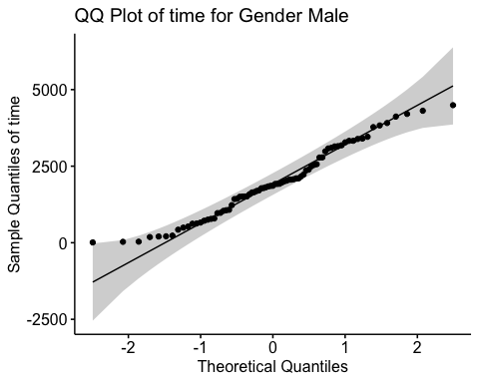
# QQ plot for 'time' for females
qq_plot(data_female, "time", "Female")
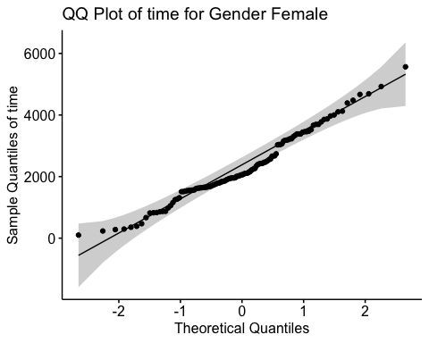
# QQ plot for 'thickness' for males
qq_plot(data_male, "thickness", "Male")
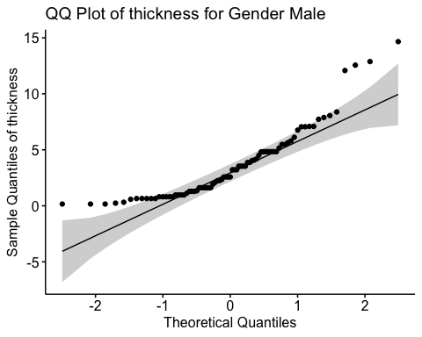
# QQ plot for 'thickness' for females
qq_plot(data_female, "thickness", "Female")
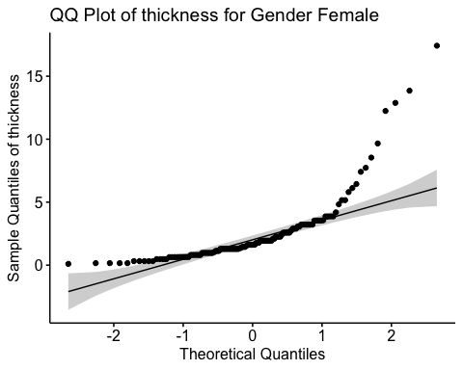
# QQ plot for 'age' for males
qq_plot(data_male, "age", "Male")
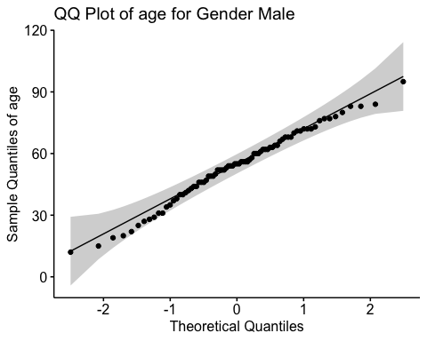
# QQ plot for 'age' for females
qq_plot(data_female, "age", "Female")
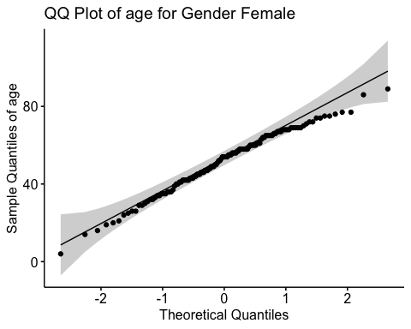

QQ-Plots and Commentary on Distribution
Here are the QQ-plots for time, thickness, and age, for both male and female groups, along with my commentary on their distributions:
The QQ-plots for the variables time, thickness, and age, grouped by gender, provide insights into their distribution relative to a normal distribution:
- Time (Male and Female):
  - Both plots show some deviation from the theoretical line, especially in the tails, suggesting that the distribution of time is not perfectly normal for either gender. This deviation is more pronounced in the upper quantiles.
- Time for Males and Females:
  - Both plots show some deviation from normality, particularly in the tails. This suggests that the distribution of time for both genders is not perfectly normal, with some skewness or outliers.
- Thickness (Male and Female):
  - For both genders, the thickness distribution shows a notable deviation from normality, particularly in the higher quantiles. This suggests a right-skewed distribution, where a few individuals have much higher thickness values than the rest.
- Thickness for Males and Females:
  - The QQ-plot for males shows greater deviation from the line, indicating a more pronounced departure from normality than in females.
  - For females, the distribution of thickness is closer to normal but still shows some deviation, especially in the upper tail.
- Age (Male and Female):
  - The age distributions for both male and female groups appear to follow the normal distribution more closely than the other variables, though there are slight deviations in the tails. This indicates a reasonably normal distribution of age in both gender groups.
- Age for Males and Females:
  - The age distribution for both males and females closely follows the normal line, indicating a roughly normal distribution for age in both genders, with some minor deviations.
These plots give us an insight into the distribution characteristics of these variables, which is important for understanding the data and choosing appropriate statistical methods.
These insights suggest that while age is approximately normally distributed, time and thickness show deviations from normality, particularly in males. These deviations might affect certain types of statistical analyses and should be considered when interpreting results.

QQ-Plots and Commentary on Distribution
# Load necessary libraries
library(ggplot2)
library(readr)
library(gridExtra)
# Load the data
melanoma_data <- read_csv("https://raw.githubusercontent.com/maz786/WlvMScAI/main/7CS039Statistics/Assessment/melanoma.csv")
# QQ-Plot function
qq_plot <- function(data, variable, gender) {
qqnorm(data[[variable]], main = paste("QQ-Plot of", variable, "for Gender", gender))
qqline(data[[variable]], col = "red")
}
# Split data by gender
data_male <- subset(melanoma_data, sex == 1)
data_female <- subset(melanoma_data, sex == 0)
# Generate QQ-Plots
# For males
par(mfrow = c(3, 1))
qq_plot(data_male, "time", "Male")
qq_plot(data_male, "thickness", "Male")
qq_plot(data_male, "age", "Male")
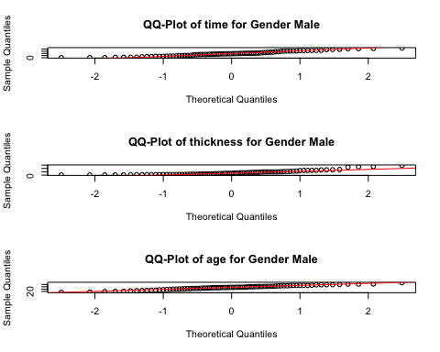
# For females
par(mfrow = c(3, 1))
qq_plot(data_female, "time", "Female")
qq_plot(data_female, "thickness", "Female")
qq_plot(data_female, "age", "Female")
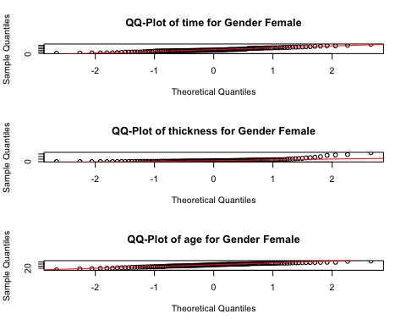

Part (vii) - Insights generated from the data analysis and provide recommendations on aspects that should be investigated in more detail

Overall Insights and Recommendations
Based on the comprehensive analysis of the melanoma dataset, here are the key insights and recommendations for further investigation:

Discussion and Recommendations

Insights from the Data:
- Variable Relationships:
  - The weak negative correlations between time and both thickness and age suggest that as thickness or age increases, the time to event or censoring decreases slightly. However, these relationships are not strong.
  - A weak positive correlation between thickness and age indicates that older patients tend to have slightly thicker melanomas.
- Gender Differences:
  - The significant differences in time and thickness between genders highlight the importance of considering gender in melanoma studies. Males tend to have thicker melanomas and shorter times to events or censoring.
- Distribution Characteristics:
  - The QQ-plots reveal that time and thickness do not follow a normal distribution perfectly, particularly in their higher values, which could affect certain types of statistical analyses.
- Summary Statistics and Graphs: Reflect on the central tendencies and distributions of the variables. Note any anomalies or patterns that stand out.
- Regression Analysis: Discuss the relationships found between variables. Identify any strong or weak correlations and their implications.
- Two-Sample T-Tests: Summarize the findings on gender differences. Highlight any significant disparities between male and female subjects in terms of time, thickness, and age.
- QQ-Plots: Comment on the normality of the data distributions and how this might affect the analysis and interpretation.

Insights:
- Variable Characteristics: The data reveals diverse characteristics in time duration, thickness, age, and other variables, indicating a heterogeneous patient population.
- Gender Differences: Significant differences in time and thickness between genders suggest the importance of considering gender as a key factor in future studies on melanoma.
- Weak Relationships: The relationships between time, thickness, and age are relatively weak, suggesting that other factors may be more critical in understanding the dynamics of melanoma progression.
- Distribution of Data: The QQ-plots indicate that while age is approximately normally distributed, time and thickness deviate from normality. This is crucial for choosing appropriate statistical methods.

Recommendations for Further Investigation:
- Explore Additional Variables:
  - Investigate other variables that might influence time, thickness, or age, such as lifestyle factors, genetic predispositions, or treatment types.
- Detailed Gender Analysis:
  - A more in-depth analysis focusing on gender differences could uncover more insights, especially considering the significant findings in time and thickness.
- Longitudinal Analysis:
  - If data over time is available for individuals, a longitudinal analysis could provide insights into the progression of melanoma and its predictors.
- Non-Parametric Methods:
  - Given the non-normal distributions of some variables, non-parametric statistical methods might be more appropriate for certain analyses.
- Clinical Relevance:
  - Collaborate with clinical experts to interpret the findings in a medical context, especially the implications of melanoma thickness and patient age.

Recommendations for Further Investigation
- Variables with Strong Relationships: Suggest more in-depth analysis or modeling for variables that showed strong relationships.
- Gender Differences: If significant differences were observed between genders, recommend exploring the reasons behind these differences.
- Data Distribution: If data distributions were not normal, consider transformation methods or non-parametric tests for future analysis.
- Additional Variables: If there are other variables that could be relevant (like lifestyle factors, geographic location, etc.), suggest including them in future studies.
- Longitudinal Analysis: If the data allows, recommend a longitudinal study to understand changes over time.

Recommendations:
- Explore Other Factors: Given the weak relationships observed, it’s recommended to explore other potential factors (like genetic, environmental, or lifestyle factors) that could influence melanoma progression.
- Focus on Gender Differences: The significant differences observed in time and thickness between genders warrant a more detailed analysis to understand the underlying reasons.
- Consider Data Transformations: For variables not normally distributed, consider transformations or non-parametric methods in future analyses to better meet the assumptions of statistical tests.
- Longitudinal Studies: If possible, conduct longitudinal studies to track changes over time, which could provide deeper insights into the progression of melanoma.
- Further Research on Subgroups: The dataset suggests possible subgroups (evidenced by multiple peaks in histograms). Investigating these subgroups might reveal more specific patterns or risk factors.
This analysis provides a foundation for understanding melanoma characteristics and paves the way for more targeted future research.

